CS571 Spring 2025 – ICA C
Web Design
Please make a copy of this document by clicking File > Make a copy. You may share and co-edit it with your fellow group members.

In this in-class activity, you will explore the concept of Web Design in three steps:

- Deconstruct a Desktop Application
- Deconstruct a Web Application for Navigation Aids
- Deconstruct a Web Application for Layout

Areas needing your response are clearly marked with Your Turn! Be sure to complete all aspects of the assignment. Your Canvas submission will be a pdf version of this document.

You may complete this in groups of 1, 2, or 3 people! :) Please be sure to assign yourself and your team member(s) to a group.

1. Deconstruct a Desktop Application
In class, you learned to deconstruct the desktop into its basic structures of windows, icons, menus, and pointers. Furthermore, you learned how to deconstruct a desktop interface into structures such as modals, panes, and toolbars. Now you get to explore these concepts by deconstructing a desktop application of your choice.

Your Turn! Considering the structures you just learned, analyze a desktop application of your choice. This could be Microsoft Word, Adobe Illustrator, Visual Studio Code, or any other substantive desktop program. Perform some basic function (format a paragraph of text, draw a picture, write some code, etc.) and answer the following questions…

- What is the desktop program that you are analyzing?
- Figma
- What is the function that you are performing?
- Analyzing a web design component using it, then implement it in CSS
- What kinds of modals, panes, toolbars, or other components supported you in completing your function?
- It has a side pane for navigating projects and drafts, a top bar for quick figma services, a secondary window showing the latest worked on projects. When choosing a project, a canvas open up that has a sidebar, a dedicated tool palette for each functionality (colors, typography.. etc)
- During some point of your function, please take a screenshot of the user interface. Then, annotate it identifying all modals, panes, and toolbars.
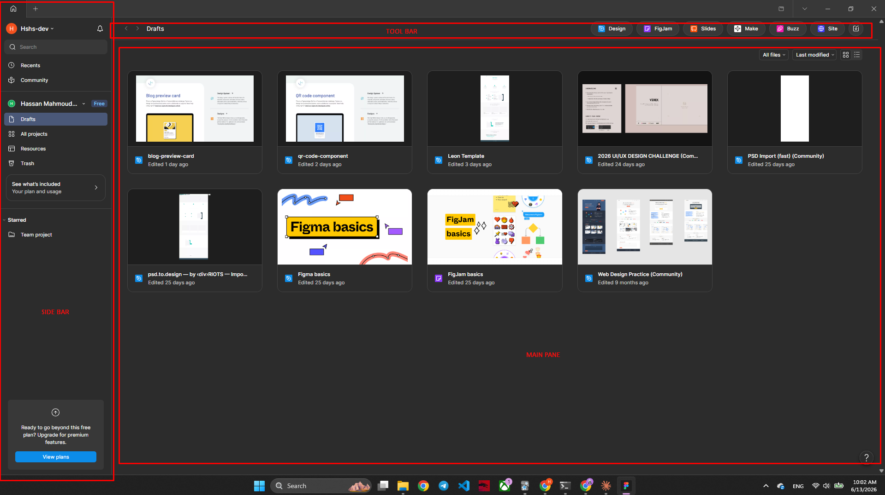
- What, if anything, would you change about the current user interface?
- I believe simplicity is the ultimate sophistication, so i will decrease the amount of buttons and functionality you deal with when looking at the main screen, hiding most stuff under menus

2. Deconstruct a Web Application for Navigation Aids
Similar to what you did in Step 1, in this step, you will deconstruct a webpage, but this time with an eye for navigation aids.

Your Turn! Considering the navigation aids you just learned, analyze a website of your choice. This could be Amazon, Channel 3000 News, GitHub, or any other substantive website. Perform some basic functions (shop for an item, read a news article, review some code, etc.) and answer the following questions…
- What is the website that you are analyzing?
- amazon.com
- What is the function that you are performing?
- shopping
- What kind of navigation aids supported you in completing your function?
- Primary navigation and search navigation
- During some point of your function, please take a screenshot of the user interface. Then, annotate it identifying all navigation aids.
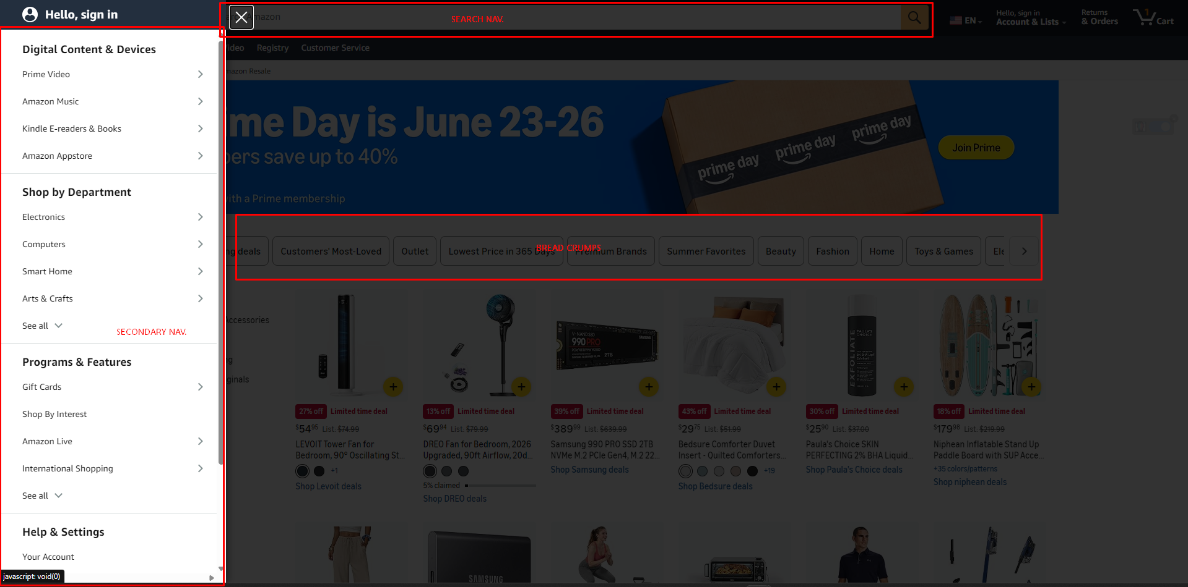
- What, if anything, would you change about the navigation of the current user interface?
- More accessible and well defined section navigation

3. Deconstruct a Web Application for Layout
Analyzing the same website as in Step 2, in this step, you will choose a particular webpage and deconstruct it with an eye for its layout.

Your Turn! Using a particular webpage of the website that you chose in Step 2, answer the following questions…

- What is the webpage that you are analyzing? Paste a screenshot below.
- anthropic.com

- Examine the 12 screen patterns introduced here. Which screen pattern is closest to your webpage’s structure? Explain your reasoning.
- It’s a mixture between tabled and wizard patterns, centered content with a simple nav bar at top and scroll to reveal

- Considering content from both “Visual Design” (last lecture) and “Web Design” (current lecture), what design techniques are being used? These could be specific design elements or principles, or more general observations.
- Heavily reliant on typography, there is a center image canvas, and 2 colors palette, white space on left and right to create a focal content point
- Balanced and symmetrical content
- What, if anything, would you change about the layout and overall aesthetics of the current user interface?
- Nothing

After completing this document, please be sure to upload it as a PDF in Canvas!

